VSware - Userguide
We use an online system for you to access information on your child’s schooling e.g. your child’s report, attendance and timetable. In order to access VSware, you will just need a username and password. The username will be issued by the school and you will create a password.
VSware is available to access through a desktop or have also just launched an App which can be downloaded on your mobile device details on how to access both is explained below along with a what you can expect once you log in.

Logging into Vsware
- Go to www.micc.ie
- Click on the Links – VSware Login
- We recommend that you use Google Chrome, Safari or Firefox. We no longer support Internet Explorer.
- Enter your username and password and hit Login
How to create your password if you don't yet have one.
- If you don't yet have a password, click Create or reset your password
- Enter your username and the last 4 digits of your mobile number, hit Send Code
- You will receive an SMS code on your mobile phone which you then enter, along with your new chosen password. Follow the instructions on screen and hit Change Password
- You will be brought back to the login screen where you can enter your username, new password and hit Login

Downloading the app and logging in via a device (phone/tablet etc.)
- For Android devices: Visit the Google Play Store on your device and search for 'VSware'
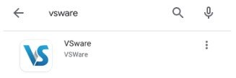
- For iOS devices (Apple): Visit the App Store on your device and search for 'VSware
- Tap 'Install'
- Once the app is on your device, start typing the name of your school, then select it from the dropdown list when it appears.
- Enter your username and password and hit Login

How to create your password if you don't yet have one.
- If you don't yet have a password, click Create or reset your password
- Enter your username and the last 4 digits of your mobile number, hit Send Code
- You will receive an SMS code on your mobile phone which you then enter, along with your new chosen password. Follow the instructions on screen and hit Change Password
- You will be brought back to the login screen where you can enter your username, new password and hit Login

Parent Dashboard

The dashboard is your one-stop-shop to view your child’s timetable, attendance, behaviour, exam results and more.
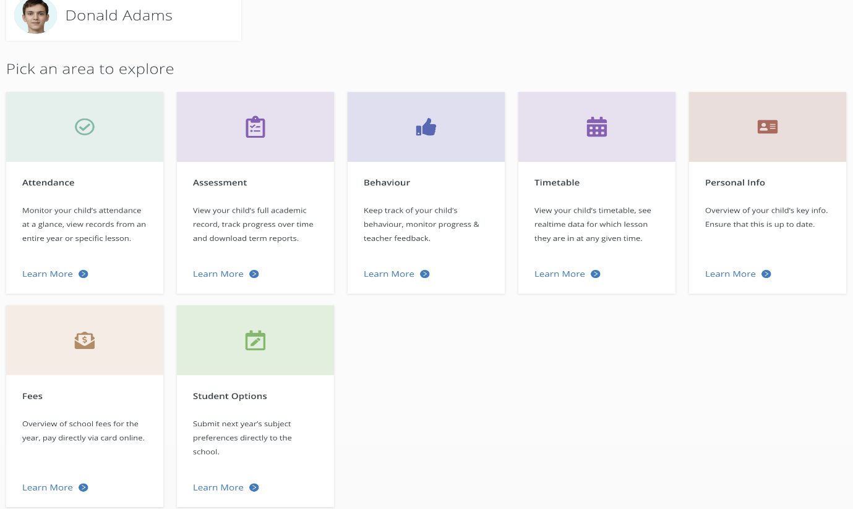
- Your Children
The Child Profile section is the central hub for all the information relation to your child. To explore information about your child, click their name either from the dashboard.
If you have multiple children at the school but some are missing from this list, contact the school who will be able to fix this for you. You should have one parent account and all your children should be on it.
- Your contact details
If these need to be updated, contact the school who can do this for you

Timetable
The Timetable screen will allow you to keep track of your child's daily routine. The red line will indicate the current time of day, so you can see at a glance which class your child is currently in.
To get to Timetable page, select your child's name from the parent dashboard or from the 'Your Children' dropdown and then click 'learn more' under Timetable.
- In the Timetable screen, you can view a week or day using the dropdown on the top left corner of the screen.
- Use the Actions button on the right to print the timetable
- Hit Today to bring you back to today's view.

- Behaviour
The Behaviour page allows you to keep track of your child's behaviour, monitor progress and read their teacher's feedback.
To get to Behaviour page, select your child's name from the parent dashboard or from the 'Your Children' dropdown and then click 'learn more' under Behaviour.
- In the Behaviour View screen, you can view the progress score and breakdown of incidents in this academic year.
- Scroll down the page to see details of each behaviour incident that has been recorded for your child including allocated if any, the date, subject and notes left by the teacher.

Attendance
On the Attendance page you can:
- Monitor attendance by year, month, day, lesson and by subject
To get to Attendance page, select your child's name from the parent dashboard or from the 'Your Children' dropdown and then click 'Learn more' under Attendance.
- Assessment
On the Assessment page you can:
- View your child’s full academic record
- Track progress over time
- Download term reports
To get to Assessment page, select your child's name from the parent dashboard or from the 'Your Children' dropdown and then click 'learn more' under Assessment.

