Maria Immaculata Community College
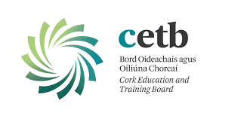
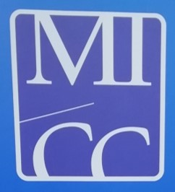
6th Year booklist 2019-20

English Keep texts from last year

Irish As for 5th year and A Thig Ná Tit Orm & Leabhar notaí, Mike Dainín Ó Sé
Edco exam papers, Higher or Ordinary level

Maths Ordinary level: Active Maths 3, 2nd edition New Single Volume ed. Folens.
Higher level: Active Maths 4, Book 2, 2nd edition, Folens
Casio calculator Only, Maths formulae and Tables,SEC,, Mathematical Set

Geography Horizons Book 1- Tara Fitzharris, Folens 2nd edition
Horizons Book 2- Tara Fitzharris, Folens 2nd edition
Edco exam papers
Accounting Accounting for Senior Cycle, Third Edition, Tyrell & Kielthy, Edco
LCVP Exam papers
Business Business Express, 2nd edition, Enda Connolly, Mentor
French Keep Tout Va Bien and keep listening/oral books from 5th year.
Ecoutez Bien LC (O).
Edco papers
Biology Leaving Certificate Biology, Revised and updated ed. 2009, Michael O' Callaghan, Edco

Physics Fusion LC Physics, Ed 1., A Carolan, 1st ed.
Graph paper and Casio calculator

Chemistry Chemistry Live and Workbook, Declan Kennedy, Folens. 2nd edition

Engineering New Engineering Technology Edition 3, Hennessy & Smith, Edco

Construction Get Constructive, Corcoran, King Nolan, Educate.ie

Tech. Graphics Graphics In Design & Communication, One Volume Ed. D. Anderson, G&M.
Drawing Set - Adjustable Set square, compass, 3H pencils, clips.
Exam papers H or O
Religion Book provided by school for non exam students

Home Economics Complete Home Economics, educate.ie from 5th yr..
Lifeline workbook 2nd ed. Enright/Flynn
Edco exam papers

Music Music LC Exam papers to be bought before returning to school

Economics Notes from school

Art Appreciating Art for Leaving Certificate, Ni Charthaigh, O'Sullivan, G&M. 2nd ed.

