Maria Immaculata Community College
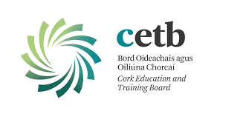
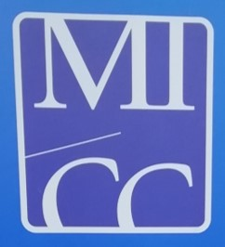
4th Year booklist 2019-20

English Make the Transition 2nd ed. Edco
Irish Taiscéal C.J. Fallon (new book)
Maths Levels will be decided in September.
Maths Formulae and Tables. Casio calculator only
Business Material will be provided in September
French On Découvre!, Transition Year French Mentor 2019
Science Folder and hand-outs
Home Economics Folder and A4 soft back copy. Booklet provided in the school
Metalwork No text book required
Religion Book provided by school
Construction Material provided in class
Technical Drawing No books/materials required.
Computers Book provided by school; Essential Computer
Applications 2nd ed., Morgan & O'Neill, G&M.
History To be confirmed in September
Geography Material provided in class
Music Copy

