Maria Immaculata Community College
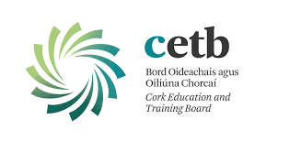
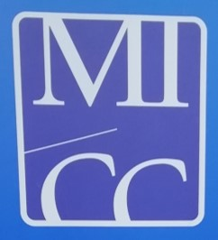
3rd Year booklist 2019-20

Most books are available through the book rental scheme. The asterisk* denotes that the book or materials are to be bought by the student before September and the double asterisk** denotes books that will be ordered in Sept and paid for by student.

English Fire and Ice 2 Folens
*Exam papers, EDCO

Irish Mol an Óige 3 (Ard)- keep workbook from 2nd year)
Mol an Óige 2 Gnáth- keep workbook from 2nd year
*Graiméar Meanscoile, CJ Fallon, D.O’Tuama, 1st ed. 2009

Maths Active Maths 1 Strands 1-5 (O&H) Keating, Mulvany, O’Loughlin
Active Maths 2 Strands 1-5 (H) only
*Casio calculator Only,
*Mathematical set,
* Maths Formulae and Tables, SEC

CSPE Make a Difference textbook 3rd ed. 2011. Keep workbook from 2nd year.

SPHE *Health and Well Being 3, EDCO. Buy before September 1

Business Business Breakthrough TB., Matt Hynes, Folens
Keep workbook from 2nd year
*EDCO exam papers including 2019
*calculator

French Allons y 2 (retain)
Ecoutez Bien(retain)
Science Essential Science textbook-Folens,
Workbook/lab notebook retained from 1st yr
*EDCO exam papers
Home Economics Lifewise 2nd ed. Randles & Kennelly, Edco.
*Lifewise workbook 2nd Ed.- keep workbook from 2nd year
*softback A4 pad
*EDCO exam papers

Art **Basic Art pack to be purchased in school. If already bought in 2nd year then there is no need to buy it again

Metalwork Basic Engineering Technology for JC new ed, Sean O Tuairisg, Fallon

Music Sounds Good Corebook, EDCO,
*Sounds Good Set C,
*Sounds Good Workbook,
*Manuscript,
*Tin whistle in D,
* Exam papers EDCO

Religion A Question of Faith 2nd ed. Whelan, McDermott, EDCO
*EDCO exam papers

Woodwork Materials Technology Wood, Gilligan, EEC Pub

Technical Graphics JC Technical Graphics new ed. P O’Callaghan, Folens.
Text and Activities Rev. Ed.

History Uncovering the Past, Folens
*Edco exam papers

Computers Basic IT Assignments, G&M. Provided by school.

Geography GEO &
*GEO w/b – keep from 2nd year., Ashe McCarthy, EDCO
*EDCO exam papers

